**WORKSHEET - 5 SQL**

**Refer to the following ERD and answer all the questions in this worksheet. You have to write the queries using MYSQL for the required Operation.**

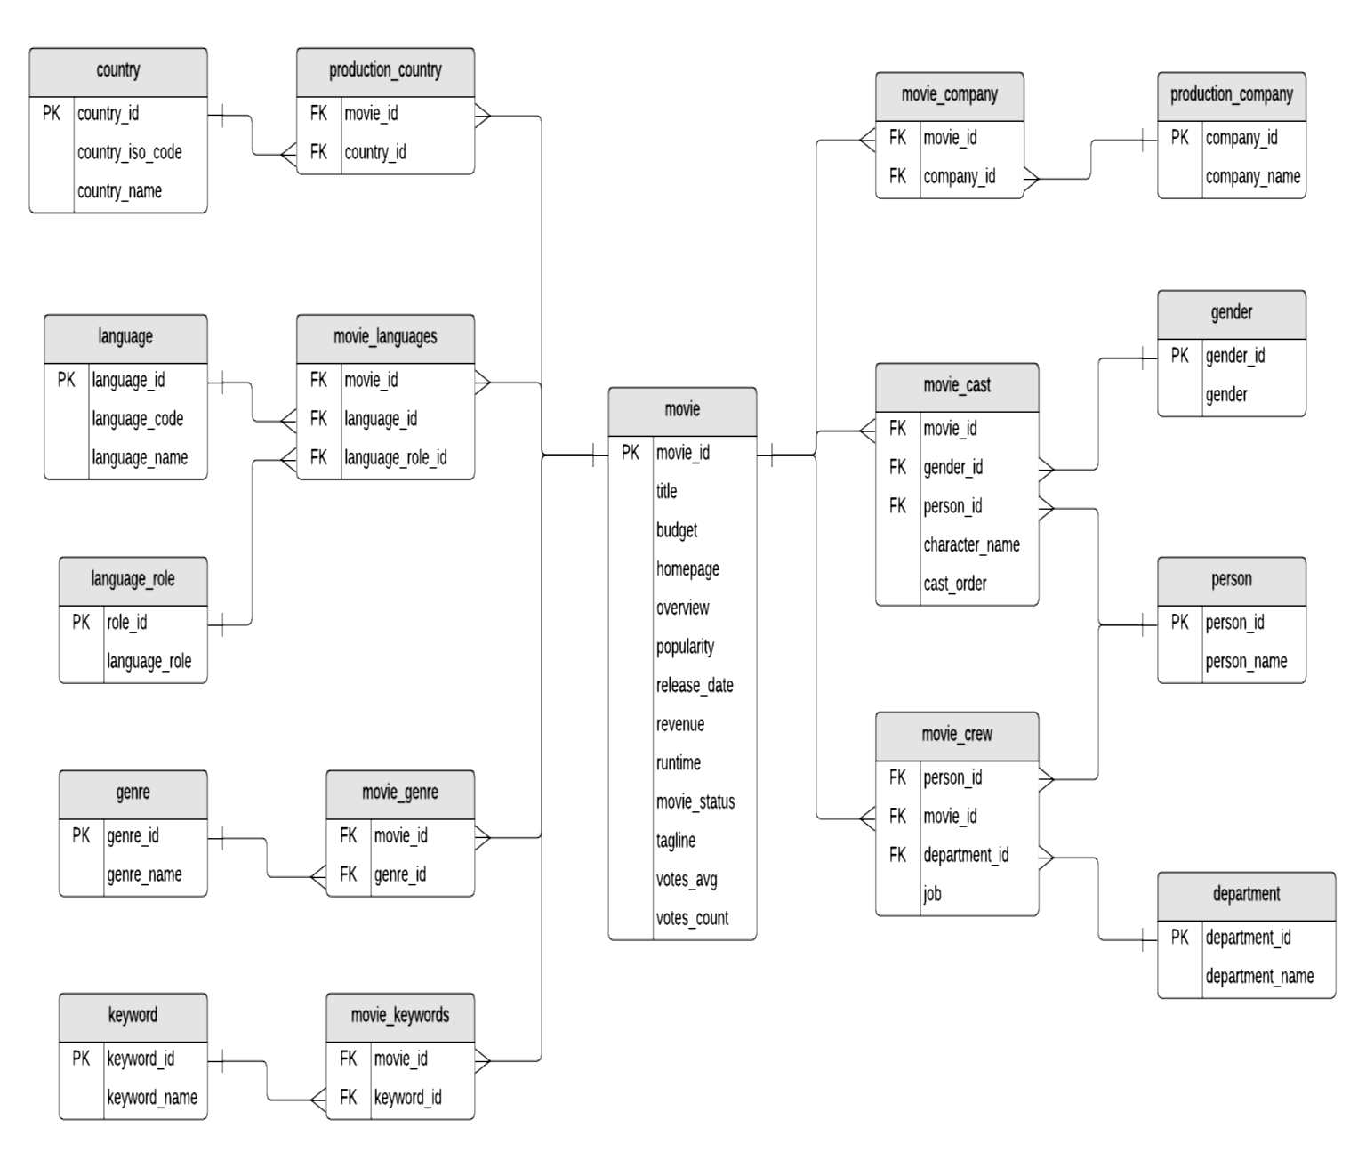

**Table Explanations:**

* The **movie** table contains information about each movie. There are text descriptions such as title and overview. Some fields are more obvious than others: revenue (the amount of money the movie made), and budget (the amount spent on creating the movie). Other fields are calculated based on data used to create the data source: popularity, votes_avg, and votes_count. The status indicates if the movie is Released, Rumoured, or in Post-Production.
* The **country** list contains a list of different countries, and the **movie_country** table contains a record of which countries a movie was filmed in (because some movies are filmed in multiple countries). This is a standard many-to-many table, and you’ll find these in a lot of databases.
* The same concept applies to the **production_company** table. There is a list of production companies and a many-to-many relationship with movies which is captured in the **movie_company** table.
* The **languages** table has a list of languages, and the **movie_languages** captures a list of languages in a movie. The difference with this structure is the addition of a **language_role** table.
* This **language_role** table contains two records: Original and Spoken. A movie can have an original language (e.g. English), but many Spoken languages. This is captured in the **movie_languages** table along with a role.
* Genres define which category a movie fits into, such as Comedy or Horror. A movie can have multiple genres, which is why the **movie_genres** table exists.
* The same concept applies to keywords, but there are a lot more keywords than genres. I’m not sure what qualifies as a keyword, but you can explore the data and take a look. Some examples as “Paris”, “gunslinger”, or “saving the world”.
* The cast and crew section of the database is a little more complicated. Actors, actresses, and crew members are all people, playing different roles in a movie. Rather than have separate lists of names for crew and cast, this database contains a table called person, which has each person’s name.
* The **movie_cast** table contains records of each person in a movie as a cast member. It has their character name, along with the **cast_order**, which I believe indicates that lower numbers appear higher on the cast list.
* The **movie_cast** table also links to the gender table, to indicate the gender of each character. The gender is linked to the **movie_cast** table rather than the **person** table to cater to characters that may be a different gender than the person or characters of unknown gender. This means that there is no gender table linked to the person table, but that’s because of the sample data.
* The **movie_crew** table follows a similar concept and stores all crew members for all movies. Each crew member has a job, which is part of a **department** (e.g. Camera).

**QUESTIONS:**

1. **Write SQL query to show all the data in the Movie table.**

Select * from movie;

1. **Write an SQL query to show the title of the longest runtime movie.**

Select title from movie order by runtime desc limit 1;

1. **Write SQL query to show the highest revenue-generating movie title.**

Select title from movie order by revenue desc limit 1;

1. **Write an SQL query to show the movie title with a maximum value of revenue/budget.**

Select title from movie order by budget desc limit 1;

1. **Write a SQL query to show the movie title and its cast details like the name of the person, gender, character name, and cast order.**

Select title, gender, character_name, cast_order, and person_name from the movie an inner join movie_cast b on a.movie_id=b.movie_id inner join gender c on

c.gender_id=b.gender_id inner join person d on d.person_id= b.person_id;

1. **Write a SQL query to show the country name where a maximum number of movies has been produced, along with the number of movies produced.**

Select country_name, count(country_name) as count from country as a inner join production_country as b on b.country_id=a.country_id group by country_name order by count desc limit 1;

1. **Write a SQL query to show all the genre_id in one column and genre_name in the second column.** Select * from genre;
2. **Write a SQL query to show the names of all the languages in one column and the number of movies in that particular column in another column.**

Select language_name,movie_id,count(language_name) from movie_languages as a join language as b on a.language_id=b.language_id group by language_name order by count(language_name) desc;

1. **Write a SQL query to show the movie name in the first column, no. of crew members in the second column, and several cast members in the third column.**

Select m.title as movie_name, count(cr.person_id) as no_of_crews, count(ca.person_id) as no_of_cast from movie as m inner join movie_crew as cr on cr.movie_id=m.movie_id inner join movie_cast ca on ca.person_id=cr_person_id;

1. **Write a SQL query to list the top 10 movies title according to the popularity column in decreasing order.**

Select title from movie order by popularity desc limit 10;

1. **Write a SQL query to show the name of the 3rd most revenue-generating movie and its revenue.**

Select title from movie order by revenue desc offset 3 limits 1;

1. **Write a SQL query to show the names of all the movies which have “rumored” movie status.**

Select title from movie where movie_status like ‘rumored’;

1. **Write a SQL query to show the title of the top 20 movies arranged in decreasing order of their budget.**

Select title from movie order by budget desc limit 20;